AutoDev
AI-Powered Multi-Agent Software Development Pipeline
Project Documentation

1. Title & Overview
AutoDev is a multi-agent AI pipeline that converts a plain-English software requirement into production-ready code, tests, and documentation — fully automatically. Built with Streamlit and powered by Groq LLMs, it orchestrates six specialized agents in sequence to handle every phase of software development.

2. Objective & Business Problem

Objective
To automate the end-to-end software development lifecycle using coordinated AI agents, reducing the time and effort required to go from requirement to deliverable code.

Business Problem
Software development is slow, expensive, and prone to human error. Teams spend significant time on boilerplate planning, architecture decisions, code reviews, test writing, and documentation. AutoDev addresses these pain points by:
- Eliminating repetitive planning and scaffolding work
- Enforcing consistent code quality through automated review loops
- Generating test suites without manual effort
- Producing documentation alongside code, not as an afterthought

3. Architecture
AutoDev follows a sequential multi-agent pipeline with a safety layer wrapping every stage:

User Requirement → Input Guardrail → Pipeline Engine → Output Guardrail → History

The Pipeline Engine contains six agents:
- Planner — defines goals, task list, tech stack, and complexity rating
- Architect — generates folder structure, design patterns, and data flow
- Developer — writes production-ready code
- Reviewer — checks for bugs and security issues; loops back to Developer if needed (max 3 iterations)
- Tester — generates pytest unit tests, integration tests, and edge cases
- Documenter — produces README, API docs, and developer guide

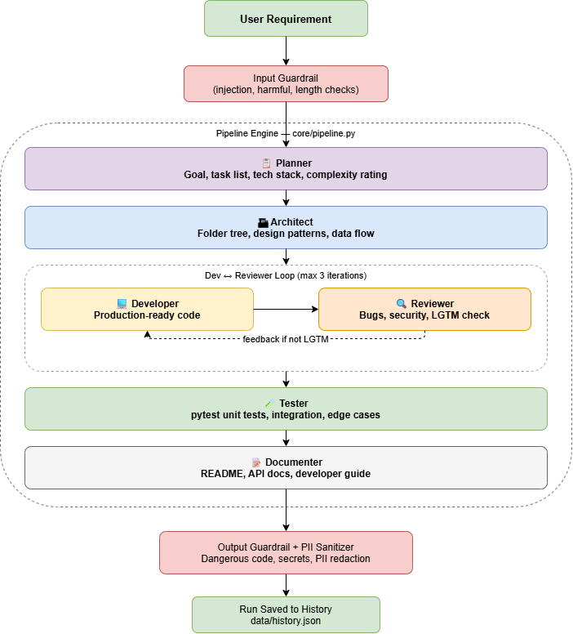

4. Approach & Pipeline
Each agent receives the accumulated context from all prior agents, ensuring full awareness at every stage. Key pipeline mechanics include:
- Sequential execution — agents run in strict order via core/pipeline.py
- Dev/Reviewer loop — the Developer and Reviewer iterate until the Reviewer confirms LGTM or 3 attempts are reached
- Context trimming — the Documenter receives only the requirement, final code, and review to avoid token limit errors
- Rate limiting — a sleep delay before the Documenter prevents TPM quota exhaustion on the LLM provider
- Three-layer guardrails — input validation, output validation, and PII sanitization run at every step
- Run history — all pipeline outputs are saved to data/history.json for audit and replay

5. Features & Limitations

Features
- Fully automated: one input produces code + tests + docs
- Safety guardrails: blocks prompt injection, harmful content, dangerous code patterns, and hardcoded secrets
- PII redaction: emails, phone numbers, SSNs, and credit card numbers are automatically sanitized
- Iterative code review: automatic Developer/Reviewer loop improves output quality
- Streamlit UI: simple web interface with run history and real-time agent status

Limitations
- Dependent on third-party LLM API (Groq) — subject to rate limits and token quotas
- Context window limits restrict the size of projects that can be generated in one run
- Generated code requires human review before deployment in production systems
- No support for multi-file interactive debugging or live code execution

6. Results
After resolving guardrail tuning and token management issues, the pipeline successfully completes end-to-end runs with all six agents passing:
- Planner, Architect, Developer, Reviewer, and Tester — complete within standard token budgets
- Documenter — runs correctly after context trimming to stay within the 6,000 TPM limit
- Guardrails — correctly distinguish real secrets from placeholder values in generated code
- PII sanitizer — redacts sensitive patterns without affecting code logic

7. Conclusion
AutoDev demonstrates that a coordinated multi-agent system can meaningfully automate software development workflows. By chaining specialized agents with robust guardrails and iterative review loops, the pipeline produces consistent, reviewable output from a single natural-language requirement.
The project also highlights practical engineering challenges in production AI pipelines: token management, guardrail calibration, and context window constraints all required deliberate design decisions.

8. Final Outcome
A working Streamlit application that accepts a plain-English software requirement and outputs:
- A structured project plan and architecture
- Reviewed, production-style source code
- A pytest test suite
- Complete project documentation (README, API docs, developer guide)
All outputs pass three layers of safety validation before being displayed to the user or saved to history.

9. Impact
AutoDev reduces the time to generate a reviewed, documented code scaffold from hours to minutes. Its modular agent design means individual agents (e.g., the Tester or Documenter) can be improved or replaced independently without rebuilding the pipeline.
As LLM context windows grow and token costs decrease, this architecture is well-positioned to scale to larger, more complex software projects — making it a practical foundation for AI-assisted development tooling.

